Novedea Systems Inc.

Project Requirements Document
For
“Contact Prospects ETL Project”

Author: Narayan Balakrishnan
Date: February 25th, 2012
Version: Final

Author Contact Email Address: Narayan_bn@hotmail.com
DOCUMENT INFORMATION AND APPROVAL

This document has been approved as the official Project Requirements Document for “Contact Prospects ETL Project”, and accurately reflects the current understanding of project requirements. Following approval of this document, requirement changes will be governed by the project’s change management process, including impact analysis, appropriate reviews and approvals.

Document Information
Version # | Date |  | Revised By | Reason for change
1.0 | 02/20/2012 |  | Narayan Balakrishnan | Initial Draft
2.0 | 02/25/2012 |  | Narayan Balakrishnan | Second Draft
3.0 | 03/11/2012 |  | Narayan Balakrishnan | Final

Document Approvals
Approver Name | Project Role |  | Signature/Electronic Approval | Date
Anand Dasari | Project Lead

Document status: X Draft __ Proposed __ Validated __ Approved

Table of Contents

1. Document Purpose 4
2. Document Resources 4
3. Glossary of Terms 4
4. Project Overview 4
4.1 Project Overview and Background 4
4.2 Project Dependencies 5
4.3 Stakeholders 5
5. Key Assumptions and Constraints 5
Key Assumptions and Constraints 5
6. ETL Methodology 6
6.1 Database Tables: 6
6.2 ETL Processing 7
6.3 ETL Task Standards 8
6.4 Comments 8
6.5 Persistent Staging Areas 8
6.6 Auditing 8
6.7 Quality 9
6.8 Source Quality 9
6.9 Transform Quality 9
6.10 Quality Check 9
6.11 Logging of Data Failures 10
6.12 ETL_QUALITY_ISSUES 10
6.13 ETL_QUALITY_AUDIT 10
7. Management Dashboard 10
Upon successful completion of the ETL Tasks, the data is ready for business users to query. However, in order to facilitate availability of the data in an efficient and quick manner, an ODS will be created that will act as a platform to provide simple and quick reports required by business users on the Management Dashboard. Pre-designed BUI Report Templates will be made available to business users on the Management Dashboard. 10
8. Traceability Matrix 11
9. Closing 12

1. Document Purpose

This document is intended to guide development of the Contact Prospects ETL Project. It will go through several stages during the course of the project:
- Draft: The first version, or draft version, is compiled after requirements have been discovered, recorded, classified, and prioritized.
- Proposed: The draft document is then proposed as a potential requirements specification for the project. The proposed document should be reviewed by several parties, who may comment on any requirements and any priorities, either to agree, to disagree, or to identify missing requirements. Readers include end-users, developers, project managers, and any other stakeholders. The document may be amended and re-proposed several times before moving to the next stage.
- Validated: Once the various stakeholders have agreed to the requirements in the document, it is considered validated.
- Approved: The validated document is accepted by representatives of each party of stakeholders as an appropriate statement of requirements for the project. The developers then use the requirements document as a guide to implementation and to check the progress of the project as it develops.

2. Document Resources

This document contains the project requirements for Contact Prospects ETL Project. These requirements have been derived from several sources, including:
- Mr. Anand Dasari at Novedea Systems, Inc.
- SQL Server 2008 Integration Services: Problem – Design – Solution Book

3. Glossary of Terms

- ETL – Extract, Transform and Load : The physical process of extracting data from a source system, transforming the data to the desired state, and loading it into a database
- CPI – Contact Prospect Information : Raw data including Contact Name, Title, Company and Location received in Excel File Formats
- QC – Quality Control
- PSA – Persistent Staging Area (Staging Tables)
- ODS – Operational Data Store
- BUI – Business User Interface

4. Project Overview

4.1 Project Overview and Background
- Project involves ETL of Contact Prospect Information (CPI) into SQL Server 2008 Database.
- CPI is received in multiple Excel Files which are the data source files.
- All the Excel Files have consistent data structure, as in the columns headers.
- “Name” Column contains Prospect Names that are in “Last Name, First Name” format. This column needs to be parsed into First Name and Last Name values and loaded into separate fields in the database.
- “Title” Column includes the Title of the contact person as well as the Department Name in some records. Title & Department Name values from this column need to be identified, separated and inserted into the respective database columns.
- “Location” Column is in the “City, St” format. This Column needs to be parsed and loaded into separate fields in the database.
- Source data needs to be loaded to Persistent Staging Area (PSA) tables, cleansed, validated, proofed, and then loaded to the Operational Data Store (ODS) tables.
- Staging Tables environment will include Framework Tables such as File_Header, File_Error, Notification_List, Stg_Contact_Error, etc., to log all activities, both success and failure/error and also to log all transactions.
- Data from PSA Tables will be integrated into the ODS Tables for additional operations on data, like Reports generation.
- ODS Tables will comply with Database Normalization rules including relationships.
- Setup Email Notifications for all ETL operations resulting in both Success and Failure.

Project Dependencies

This Project will focus on the Contacts Table which is related to several tables:
- Title Table
- Department Table
- Company Table
- Location Table

4.3 Stakeholders
The following comprises the internal and external stakeholders whose requirements are represented by this document:

 | Stakeholders
1. | Anand Dasari
2. | Narayan Balakrishnan
3.

5. Key Assumptions and Constraints

Key Assumptions and Constraints
Assumptions:
- Source data is always received in EXCEL File Formats
- Source data within the EXCEL Files is always in the same order, i.e., Name, Title, Company and Location
- No additional columns of data are included in the source Excel Files.

Constraints:
- Primary Keys Foreign Keys
- Unique Values Null Values
- Default Values
6. ETL Methodology

6.1 Database Tables:

The following section documents the ETL Methodology that is proposed for this project.

For this Project, five types of tables will be used: Audit, Staging, Aggregate, Dimension and ODS. The various database tables that will be created and utilized for this project are listed below by table types.

Audit Table – a table used to keep track of the ETL process (ex. File_Header Tables with number of records inserted, date time stamp, etc.)
- Aud_File_Header
- Aud_File_Error
- Aud_Contacts_Error
- Aud_Title_Error
- Aud_Company_Error
- Aud_Dept_Error
- Aud_Location_Error
- Aud_Notification_List

Staging Table – a table used to store data during ETL processing but the data is not removed immediately
- Stg_Contacts
- Stg_Title
- Stg_Company
- Stg_Dept
- Stg_Location

Aggregate Table – a table type used to aggregate data, forming a pre-computed answer to a business question (ex. Row count of records inserted per file on a given day)
- Agr_Contacts_RowCnt
- Agr_Title_RowCnt
- Agr_Company_RowCnt
- Agr_Dept_RowCnt
- Agr_Location_RowCnt

Dimension Table – a table type that contains referential data needed by the fact tables
- Dim_Address_Data
- Dim_City_Data
- Dim_State_Data

ODS Table – a table containing atomic data (data elements that represent the lowest level of detail).
- Ods_Contacts
- Ods_Title
- Ods_Company
- Ods_Department
- Ods_Location

Below is a Database Diagram illustrating the proposed “Contact Prospects Database”:

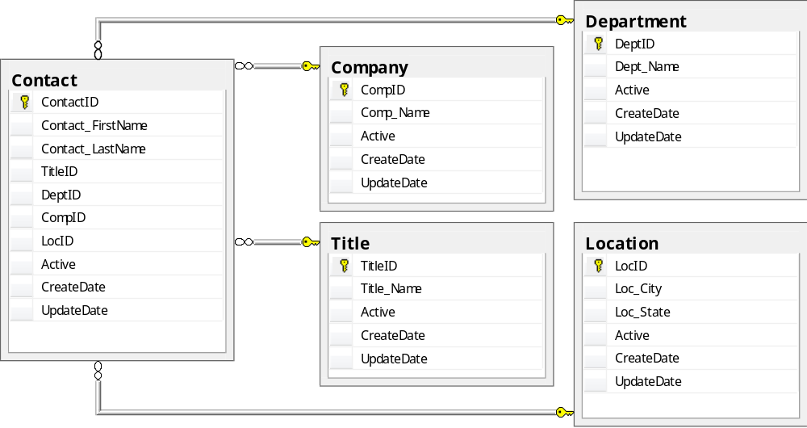

6.2 ETL Processing
There following types of ETL Tasks will be used for processing. This table lists the task type, naming convention, and explains the task functions.

Task Type | Explanation | Naming Convention
Extract | Extracts information from a source systems & places in a staging table | Extract<Source><Subject>  ExtractDICustomer
Source | Sources information from STG tables & performs column validation | Source<Table>  SourceSTGDICustomer
LoadTemp | Load temp tables used in processing | LoadTemp<Table>  LoadTempETLAddressTemp
LookupDimension | Lookup dimension tables | LookupDimension<Subject>  LookupDimensionCustomer
Transform | Transform the subject area data and generate insert files | Transform<Subject>  TransformCustomer
QualityCheck | Checks the quality of the data before loaded into the ODS | QualityCheck<Subject>  QualityCheckCustomer
Load | Load the data into the ODS | Load<Table>  LoadODSCustomerFact

6.3 ETL Task Standards

All ETL tasks will be created with a boiler-plate approach. This approach allows for rapid creation of similar tasks while keeping maintenance low. Each Task will be associated with a “Send Mail” Task that will notify the Project members on the status of the task.

6.4 Comments

Every task will have a standard comment template that specifically spells out the following attributes of the task:

Task Name: LoadODSContactFact
Purpose: Load the ODS_Contact_Fact table
Predecessor: QualityCheckContact
Date: February 21, 2012
Author: Narayan Balakrishnan
Revision History:
February 21, 2012 – Created the task from standard template

In addition there will also be a task data dictionary that describes every task in a table such that it can be easily searched via standard SQL.

6.5 Persistent Staging Areas

Data will be received from the source systems in its native format. The data will be stored in a PSA table following the naming standards listed previously. The table will contain the following layout:

Column | Data Type | Explanation
ROW_NUMBER | NUMBER | Unique for each row in the PSA
DATE | DATE | Date row was placed in the PSA
STATUS_CODE | CHAR(1) | Indicates status of row (‘I’ inducted, ‘P’ processed, ‘R’ rejected)
ISSUE_CODE | NUMBER | Code uniquely identifying problems with data if STATUS_CODE = ‘R’
BATCH_NUMBER | NUMBER | Batch number used to process the data (auditing)
Data columns to follow

6.6 Auditing

The ETL methodology maintains a process for providing audit and logging capabilities.

For each run of the process, a unique batch number composed of the time segments is created. This batch number is loaded with the data into the PSA and all target tables. In addition, an entry with the following data elements will be made into the ETL_PROCESS_AUDIT table.

Column | Data Type | Explanation
DATE | DATE | (Index) run date
BATCH_NUMBER | NUMBER | Batch number of process
PROCESS_NAME | VARCHAR | Name of process that was executed
PROCESS_RUN_TIME | TIMESTAMP | Time (HH:MI:SS) of process execution
PROCESS_STATUS | CHAR | ‘S’ SUCCESS, ‘F’ FAILURE
ISSUE_CODE | NUMBER | Code of issue related to process failure (if ‘F’)
RECORD_PROCESS_COUNT | NUMBER | Row count of records processed during run

The audit process will allow for efficient logging of process execution and encountered errors.

6.7 Quality

Due to the sensitive nature of data within the ODS, data quality is a driving priority. Quality will be handled through the following processes:

- Source task - the source task will contain a quick data scrubbing mechanism that verifies the data conforms to the expected type (Numeric is a number and character is a letter).
- Transform – the transform task will contain matching metadata of the target table and verify that NULL values are not loaded into NOT NULL columns and that the data is transformed correctly.
- QualityCheck – a separate task is created to do a cursory check on a few identified columns and verify that the correct data is loaded into these columns.

6.8 Source Quality

A data scrubbing mechanism will be constructed. This mechanism will check identified columns for any anomalies (ex. Embedded carriage returns, Leading and Trailing Spaces) and value domains. If an error is discovered, the data is fixed and a record is written in the ETL_QUALITY_ISSUES table (see below for table definition).

6.9 Transform Quality

The transformation task will employ a matching metadata technique. If the target table enforces NOT NULL constraints, a check will be built into the task preventing NULLS from being loaded.

6.10 Quality Check

Quality check is the last point of validation within the task stream. QC can be configured to check any percentage of rows (0-100%) and any number of columns (1-X). QC is designed to pay attention to the most valuable or vulnerable rows with the data sets. QC will use a modified version of the data scrubbing engine used during the source task to derive correct values and reference rules listed in the ETL_QC_DRIVER table. Any suspect rows will be pulled from the insert/update files, updated in the PSA table to an ‘R’ status and create an issue code for the failure.

6.11 Logging of Data Failures

Data that fails the QC task will not be loaded into the ODS based on defined rules. An entry will be made into the following table (ETL_QUALITY_ISSUES). An indicator will show the value of the column as defined in the rules (‘H’ HIGH, ‘L’ LOW). This indicator will allow resources to be used efficiently to trace errors.

6.12 ETL_QUALITY_ISSUES

Column | Data Type | Explanation
DATE | DATE | Date of entry
BATCH_NUMBER | NUMBER | Batch number of process creating entry
PROCESS_NAME | VARCHAR | Name of process creating entry
COLUMN_NAME | VARCHAR | Name of column failing validation
COLUMN_VALUE | VARCHAR | Value of column failing validation
EXPECTED_VALUE | VARCHAR | Expected value of column failing validation
ISSUE_CODE | NUMBER | Issue code assigned to error
SEVERITY | CHAR | ‘H’ HIGH, ‘L’ LOW

6.13 ETL_QUALITY_AUDIT

Column | Data Type | Explanation
DATE | DATE | Date of entry
BATCH_NUMBER | NUMBER | Batch number of process creating entry
PROCESS_NAME | VARCHAR | Name of entry creating process
RECORD_PROCESS_COUNT | NUMBER | Number of records processed
RECORD_COUNT_CHECKED | NUMBER | Number of records checked
PERCENTAGE_CHECKED | NUMBER | Percentage of checked records out of data set
7. Management Dashboard

Upon successful completion of the ETL Tasks, the data is ready for business users to query. However, in order to facilitate availability of the data in an efficient and quick manner, an ODS will be created that will act as a platform to provide simple and quick reports required by business users on the Management Dashboard. Pre-designed BUI Report Templates will be made available to business users on the Management Dashboard.
Reports will be designed using SSRS. The following Reports will be included on the Dashboard:
Individual Reports for:
- Top 5 Cities, States, Departments & Title for Contact Prospects
- Count summaries by Cities, States, Department & Title
- Exception Handling Report – Displays all errors from ETL for given date range
Sample Report Template1:

Top 5 Cities Report
 | CITY NAME | COUNT |  |  | RANK
 | Chicago | 1900 |  |  | 1
 | Los Angeles | 1800 |  |  | 2
 | New York | 1600 |  |  | 3
 | Florida | 1400 |  |  | 4
 | Houston | 1200 |  |  | 5

Sample Report Template2:

Exception Handling Report
 | DATE | ERROR | COUNT | ERROR_TABLE
 | 1/1/2012 | Missing Department Name | 15 | Err_Dept
 | 1/2/2012 | Missing Title | 12 | Err_Title
 | 1/3/2012 | Missing City | 27 | Err_City
 | 1/4/2012 | Missing State | 19 | Err_State
8. Traceability Matrix

Requirement Identifiers | Reqs Tested | ETL | ETL | ETL | AUD | AUD | AUD | ODS | ODS | ODS | FINAL | FINAL | FINAL
Requirement Identifiers | Reqs Tested | 1.1 | 1.2 | 1.3 | 2.1 | 2.2 | 2.3 | 3.1 | 3.2 | 3.3 | 4.1 | 4.2 | 4.3
Test Cases
Tested Implicitly
1.1.1
1.1.2
Etc.
9. Closing

After reading this ETL document you should have a better understanding of the issues associated with ETL processing. This methodology has been created to address as many negatives as possible while providing a high level of performance and ease of maintenance while being scalable and workable in a real-time ETL processing scenario.

